**Client Intake Form**

Name

Address

Postcode

Phone Number

Emergency Contact

Date of Birth/Age

Occupation

Email :

**Massage Info**

How do you hear about me.?

Have you received a massage therapy before

If yes what type of massage? Indicate below:

Do you suffer with chronic pain?

If so, please detail:

Do you have any orthopedic injuries?

If yes please detail :

Do you exercise regularly?

Do you see a chiropractor? If so how often?

Do you sit for long periods at a computer/work/driving?

What typer of pressure do you require?

Light/Medium or Firm?

Please indicate on the pictures below where you are feeling tense or are experiencing discomfort.

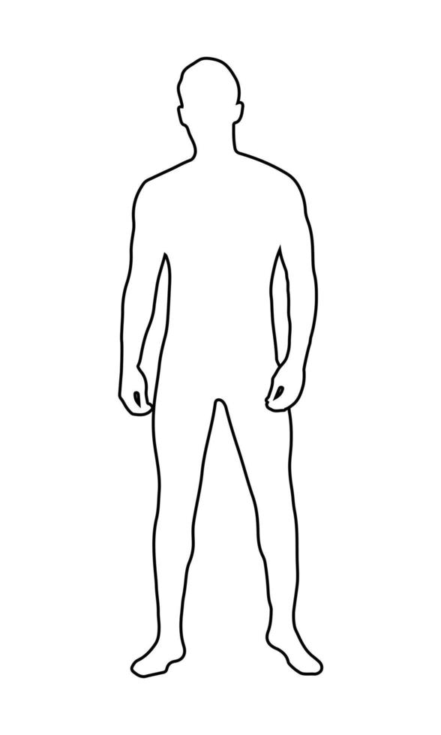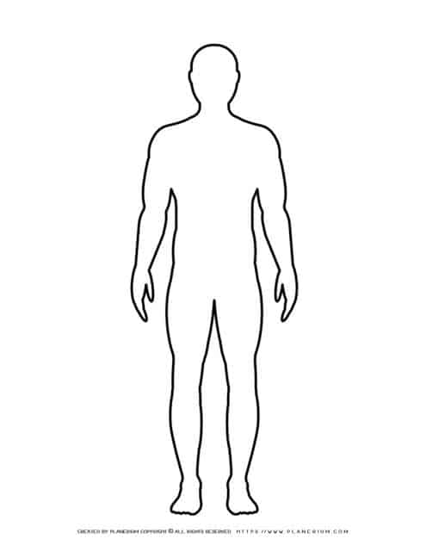

Medical History please tick if you have any of the following:

* Cardi Vascular issues
* Bleeding Disorder
* **Low blood pressure**
* **High Blood pressure**
* Numbness Tingling
* Skin conditions
* Unhealed wounds
* Heart Kidney disease
* Hives Herpes Shingles
* **Headache/Migraine**
* Surgical incisions
* Vertigo Dizziness
* Fungal Condition
* Pregnant Breastfeeding
* Poor circulation
* **Epilepsy Seizures**
* Loss of sensation
* Joint Muscle Pain
* Thyroid
* **Menstruation**
* **Asthma**
* **Bruising**
* **Cuts/abrasions**
* **Heavy Meal**
* **Hernia**
* Transplants
* Arthritis
* **Allergies**
* **Diabetes**
* **Drugs/Alcohol**
* **Eczema/psoriasis**
* **Recent scar tissues**
* **Sunburn**
* **Swelling medical odema**
* **Meningitis**
* **Recent head or neck injury**
* Depression
* Fibromyalgia
* Sensory Loss
* Osteoporosis
* Inflammation
* Insomnia
* **Varicose veins**
* Skin Cancer
* Fever
* Cancer
* Anxiety
* HIV
* Lupas
* Sciatica
* Stress
* Stroke
* Rashes
* Fracture
* Fatigue

Are you taking ay medications please list:

Do you have any allergies to or sensitivity to oil lotions fruits or nuts? If so, please indicate?

How much alcohol do you drink in units each week?

Do you smoke if so, how often?

By signing this form, you agree to the following and understand this massage is not a replacement for medical care and no diagnosis will be made?

Client Signature

Therapist Signature

Date